

**Faculty of Engineering & Technology – Electrical & Computer Engineering Department**

**First Semester 2022 – 2023**

**Circuits and electronics lab**

**ENEE2103**

**Prelab experiment 11**

**Name: Amal Ziad**

**ID: 1192141**

**Section: 2**

**Instructor: Dr. Mohammad Jehad Al Juba**

**TA: Eng. Yazan Yousef**

**Date: 6th Jan 2023**

# ZENER DIODE.

## Zener diode with 1 kΩ resistor

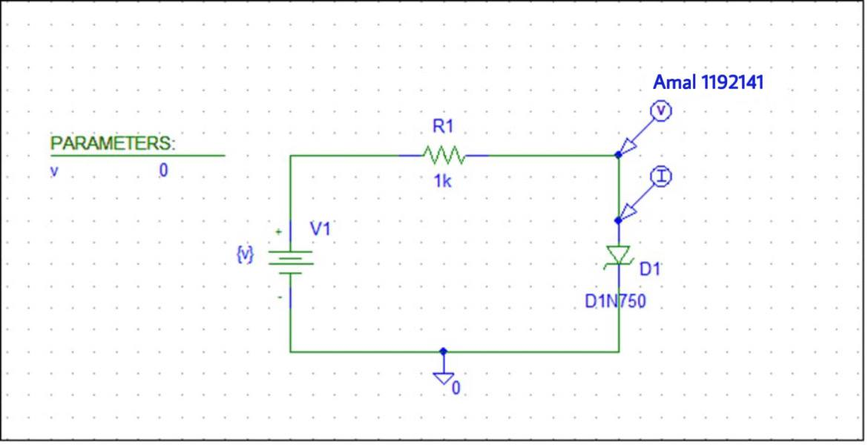

* Zener voltage (Vo) **:**



* Current in the circuit: (Iz) :

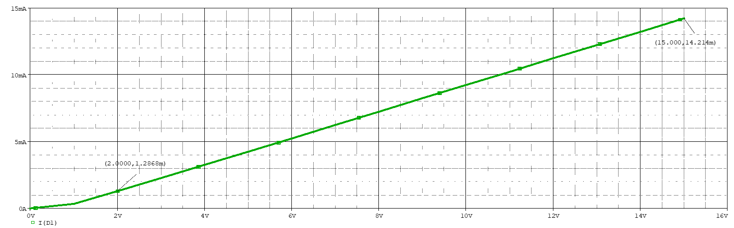

# 1.2 Zener diode with 100 Ω resistor

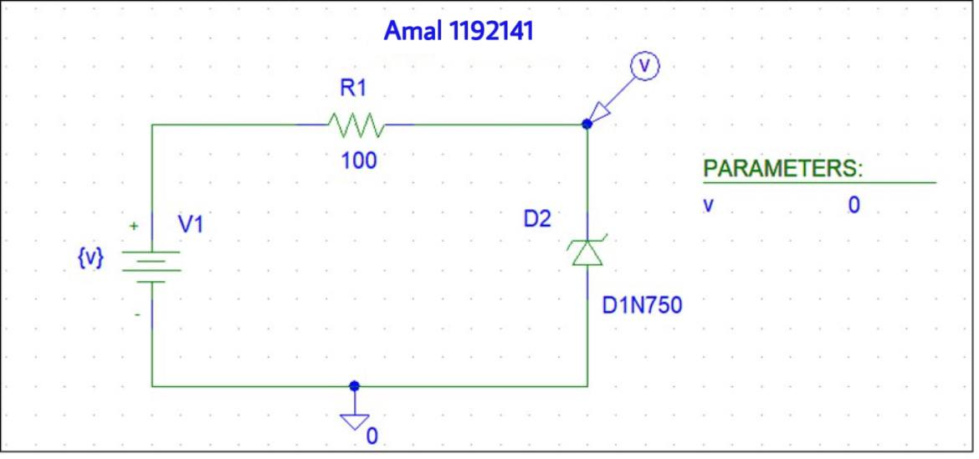

* Zener voltage (Vo) **:**



* Current in the circuit: (Iz) :



# 1.3 Zener diode with load resistor

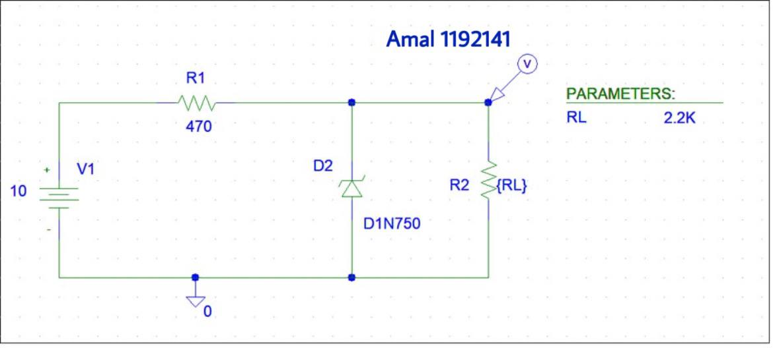

* Voltage across the load resistor:



* Voltage across RL after applying DC sweep for it, and the input voltage is 10 V:



# THE VOLTAGE REGULATED POWER SUPPLY.

## 2.1 Op amp series voltage regulator

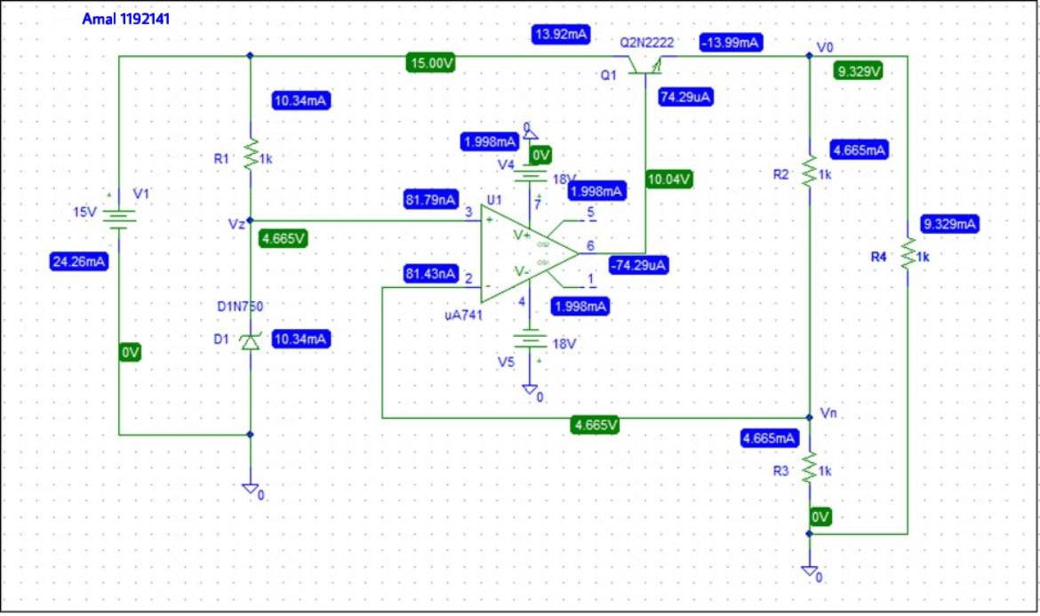

From the bias point analysis of the circuit:

* Vo = 9.329v
* Vz = 4.665v

The relation between Vo and Vz.

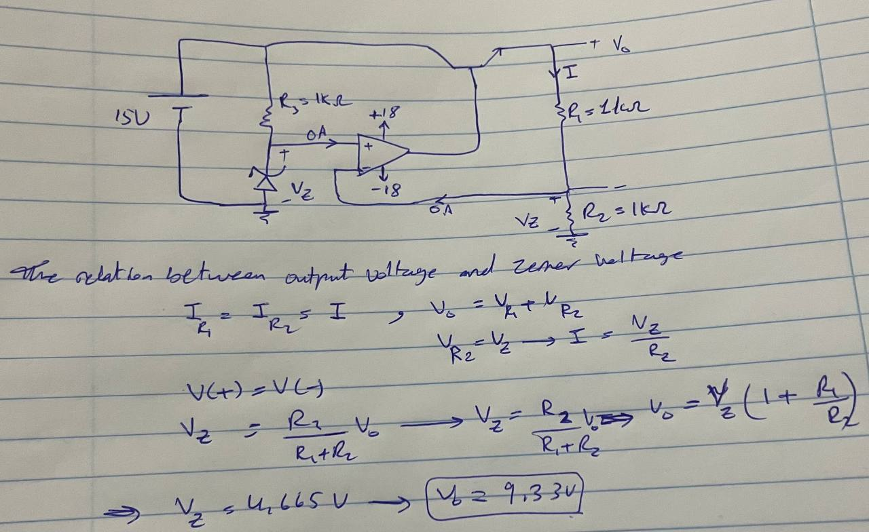

* Attach a 1k load resistor to the output



* Vo=9.329V

Vo:

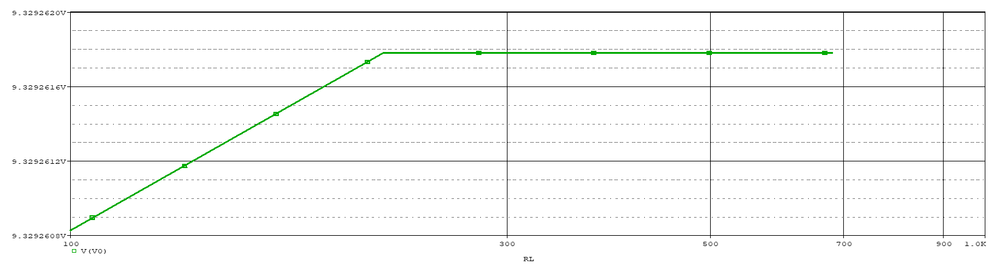

Io:

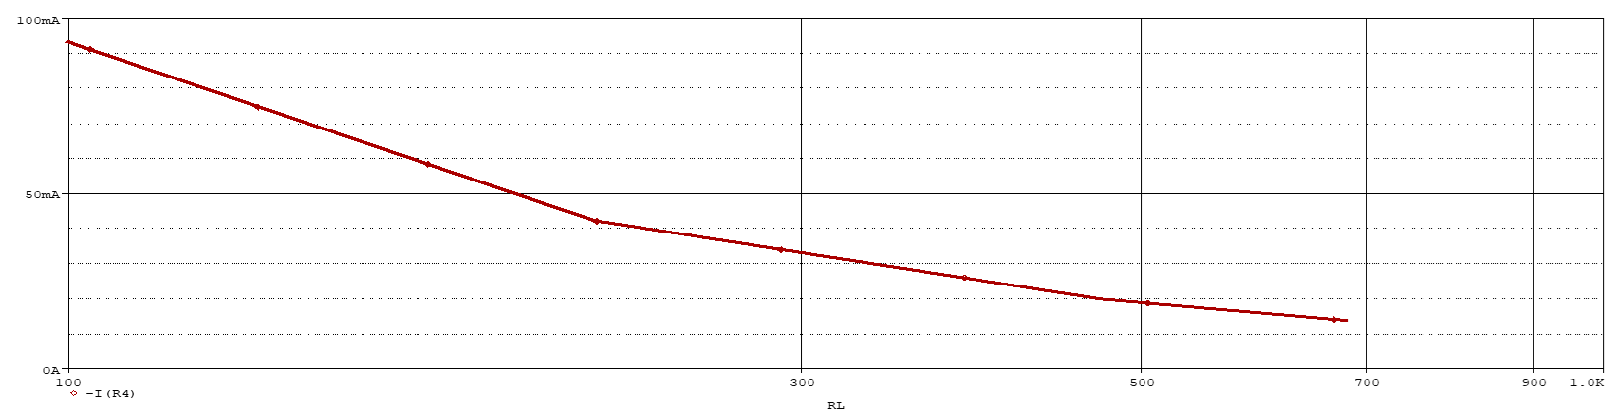

* Changing RL to 1 kΩ, R3 to470 Ω:

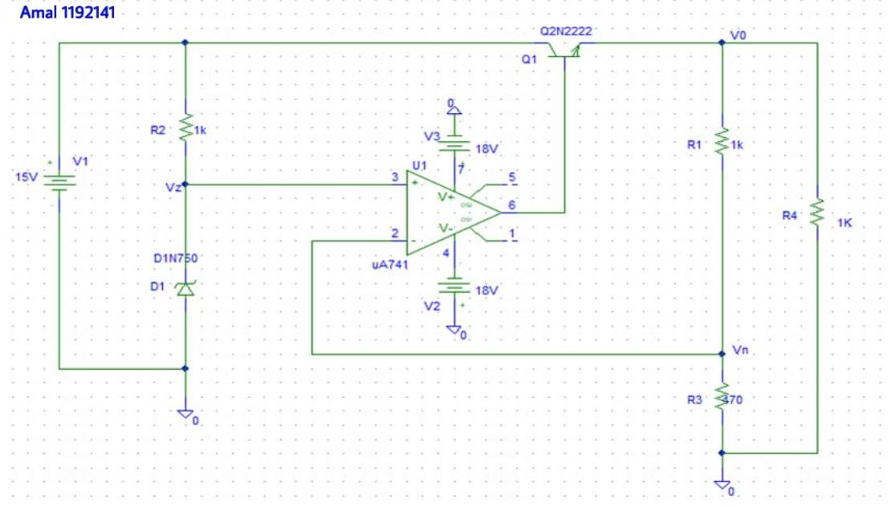

* Bias point analysis:

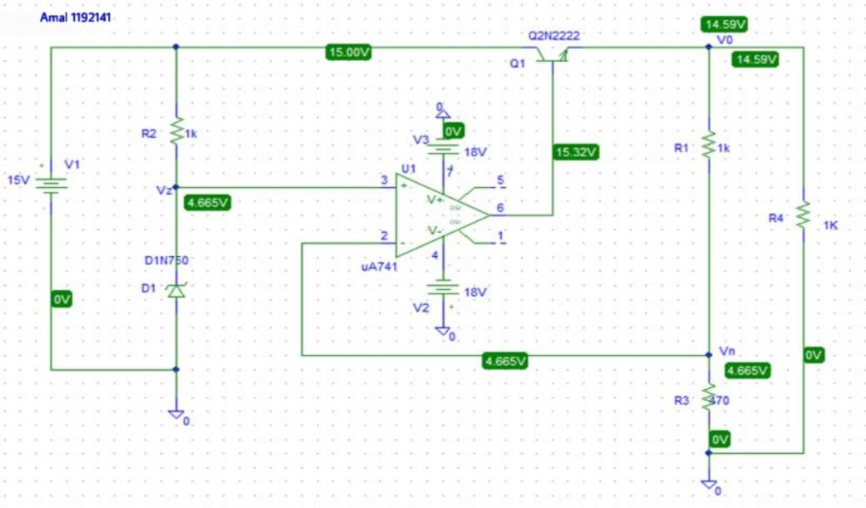

Vo=14.59V, Vz=4.665V

* Changing RL to 1 kΩ, R3 to 2.2 kΩ:

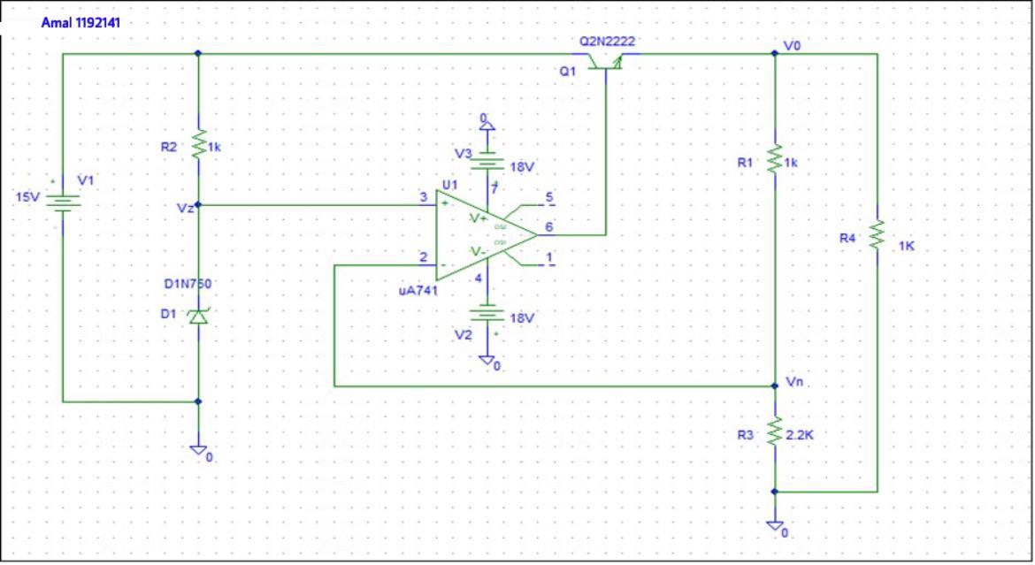

* Bias point analysis:

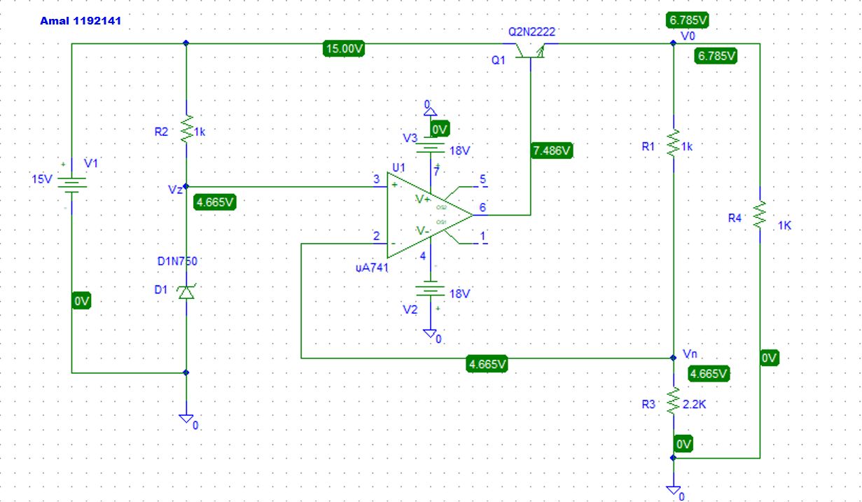

Vo=6.785V , Vz=4.665V

## 2.2 Op amp series voltage regulator with current limit

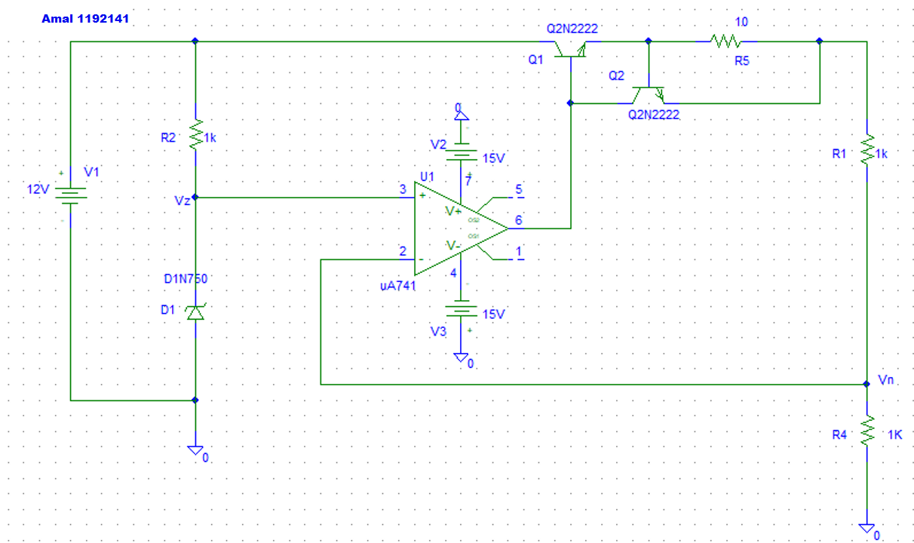

* Bias point analysis:

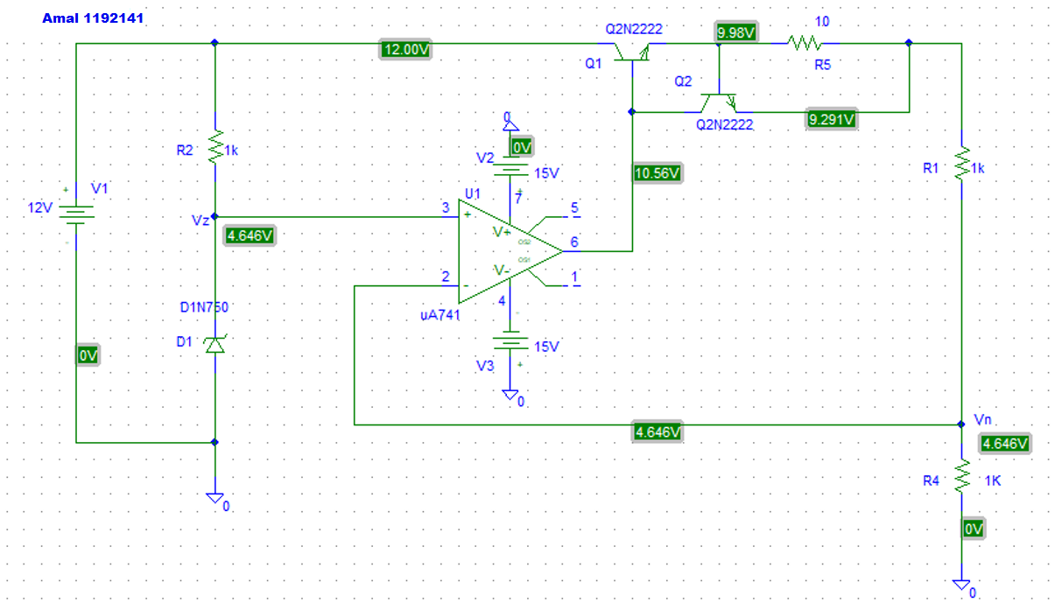

Vo=9.291 V

Vo:

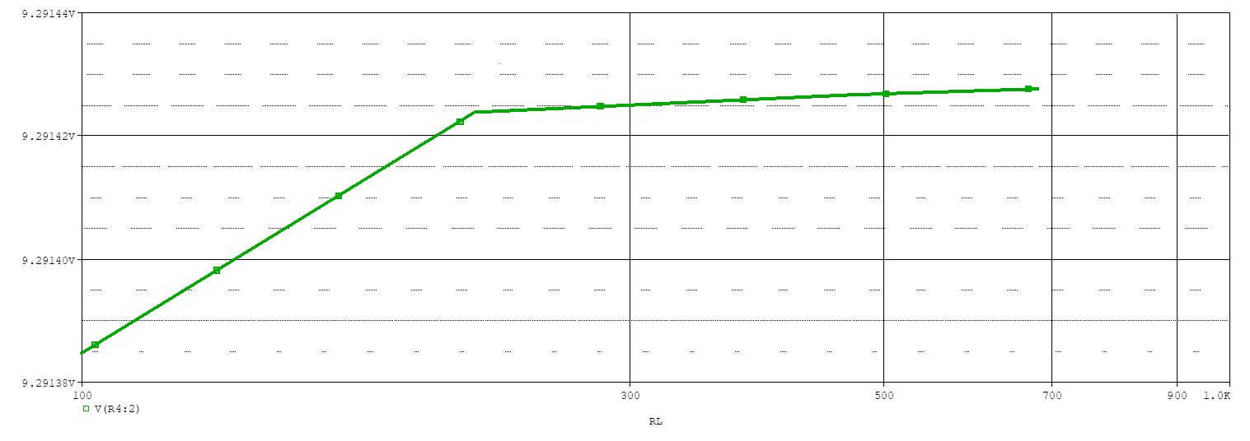

Io:

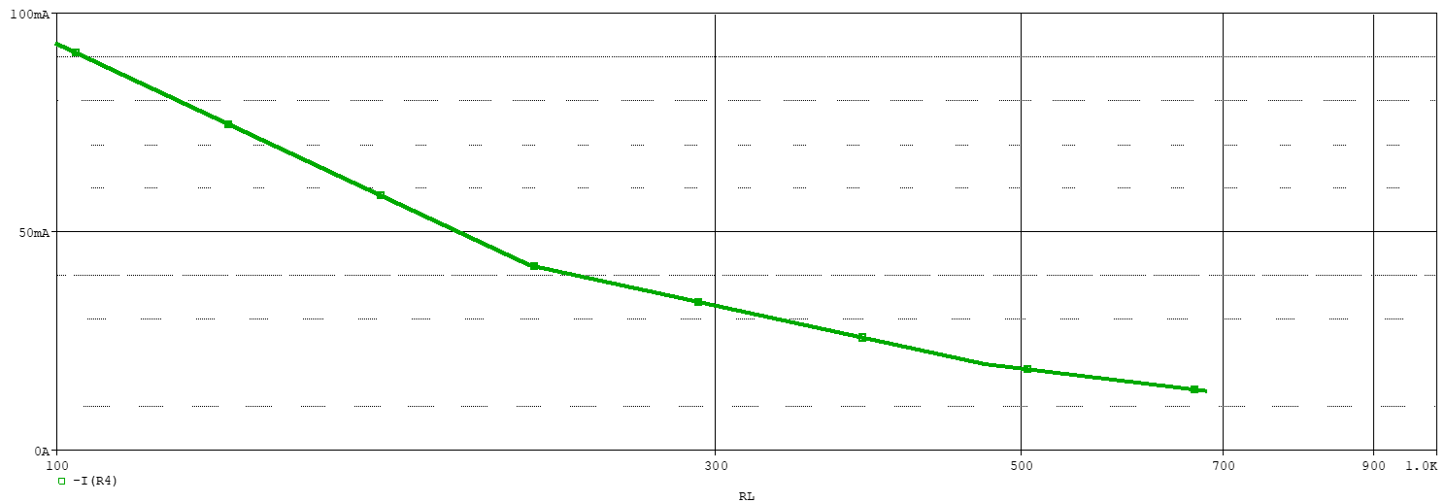

* Change RL to 1 kΩ, R3 to 470 Ω:

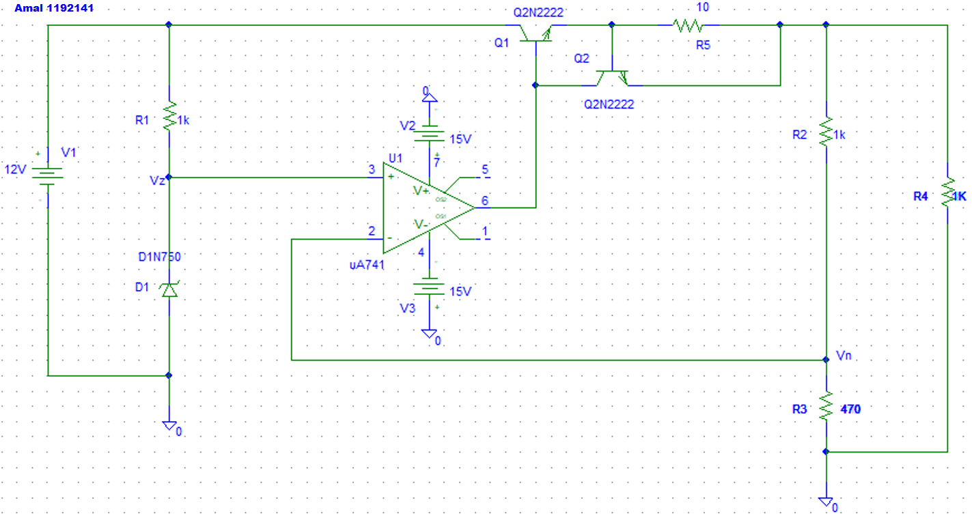

* Bias point analysis:

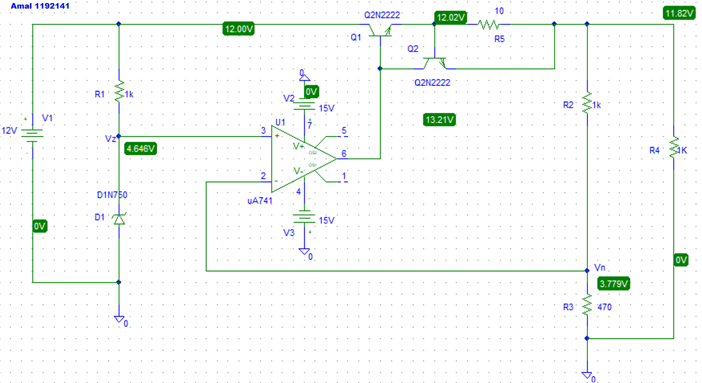

Vo=11.82 V